Exercise 2: E-commerce Platform Search Function

CODE:

import java.util.Arrays;  
import java.util.Comparator;  
class Product {  
 int productId;  
 String productName;  
 String category;  
 public Product(int var1, String var2, String var3) {  
 this.productId = var1;  
 this.productName = var2;  
 this.category = var3;  
 }  
 public String toString() {  
 return this.productId + " - " + this.productName + " (" + this.category + ")";  
 }  
}  
class SearchEngine {  
 public SearchEngine() {  
 }  
 public static Product linearSearch(Product[] var0, String var1) {  
 Product[] var2 = var0;  
 int var3 = var0.length;  
  
 for(int var4 = 0; var4 < var3; ++var4) {  
 Product var5 = var2[var4];  
 if (var5.productName.equalsIgnoreCase(var1)) {  
 return var5;  
 }  
 }  
 return null;  
 }  
 public static Product binarySearch(Product[] var0, String var1) {  
 int var2 = 0;  
 int var3 = var0.length - 1;  
 while(var2 <= var3) {  
 int var4 = var2 + (var3 - var2) / 2;  
 int var5 = var0[var4].productName.compareToIgnoreCase(var1);  
 if (var5 == 0) {  
 return var0[var4];  
 }  
  
 if (var5 < 0) {  
 var2 = var4 + 1;  
 } else {  
 var3 = var4 - 1;  
 }  
 }  
 return null;  
 }  
}  
public class Ecommerce {  
 public static void main(String[] var0) {  
 Product[] var1 = new Product[]{new Product(101, "Laptop", "Electronics"), new Product(102, "Shoes", "Fashion"), new Product(103, "Phone", "Electronics"), new Product(104, "Bag", "Accessories"), new Product(105, "Watch", "Fashion")};  
 System.*out*.println("Linear Search Result:");  
 Product var2 = SearchEngine.*linearSearch*(var1, "Phone");  
 System.*out*.println(var2 != null ? var2 : "Product not found");  
 System.*out*.println("\nBinary Search Result:");  
 Arrays.*sort*(var1, Comparator.*comparing*((var0x) -> {  
 return var0x.productName.toLowerCase();  
 }));  
 Product var3 = SearchEngine.*binarySearch*(var1, "Phone");  
 System.*out*.println(var3 != null ? var3 : "Product not found");  
 }  
}

OUTPUT:

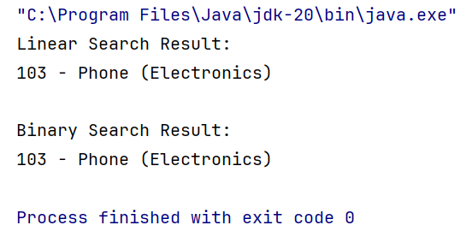

Exercise 7: Financial Forecasting

CODE:

public class FinancialForecast {  
  
 public static double calculateFutureValue(double presentValue, double growthRate, int periods) {  
 if (periods == 0)  
 return presentValue;  
 return *calculateFutureValue*(presentValue, growthRate, periods - 1) \* (1 + growthRate);  
 }  
  
 public static double calculateFutureValueIterative(double presentValue, double growthRate, int periods) {  
 for (int i = 0; i < periods; i++) {  
 presentValue \*= (1 + growthRate);  
 }  
 return presentValue;  
 }  
  
 public static void main(String[] args) {  
 double presentValue = 10000;  
 double annualGrowthRate = 0.08;  
 int years = 5;  
 double futureValue = *calculateFutureValue*(presentValue, annualGrowthRate, years);  
 System.*out*.printf("Future value after %d years: ₹%.2f\n", years, futureValue);  
 }  
}

OUTPUT:

